IAM Users Assignment-1

1. **Create 4 IAM users named “Dev1”, “Dev2”, “Test1”, and “Test2”.**

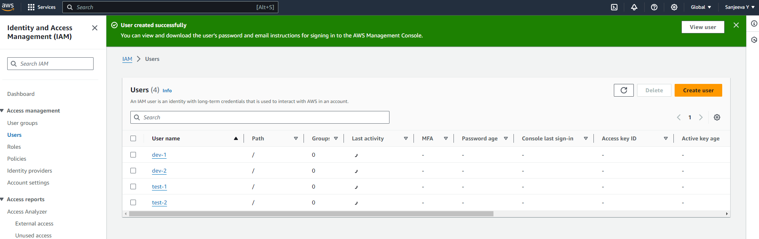

1. **Create 2 groups named “Dev Team” and “Ops Team”.**

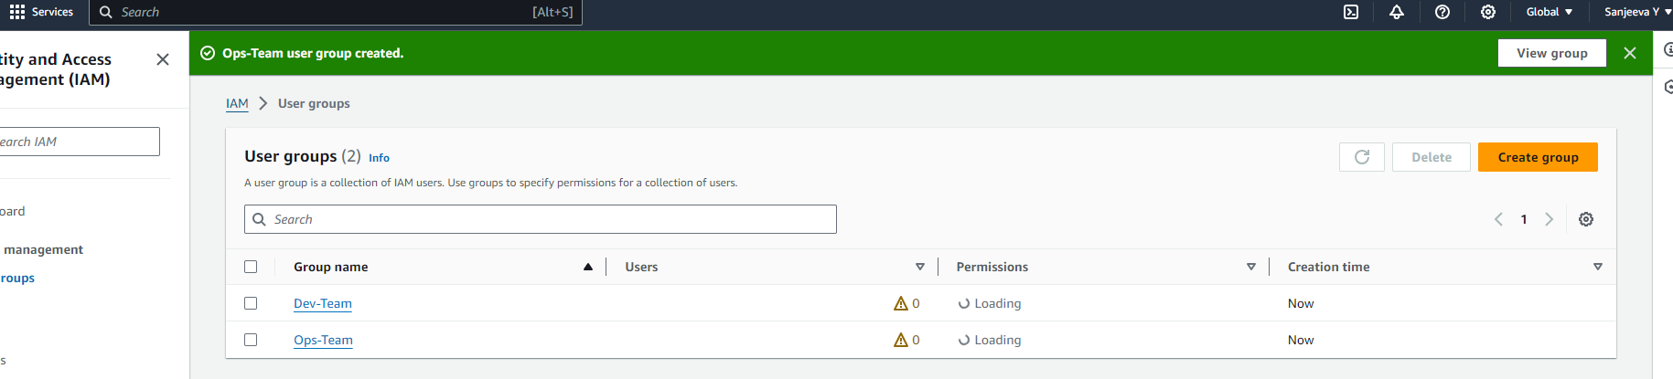

1. **Add Dev1 and Dev2 to the Dev Team.**

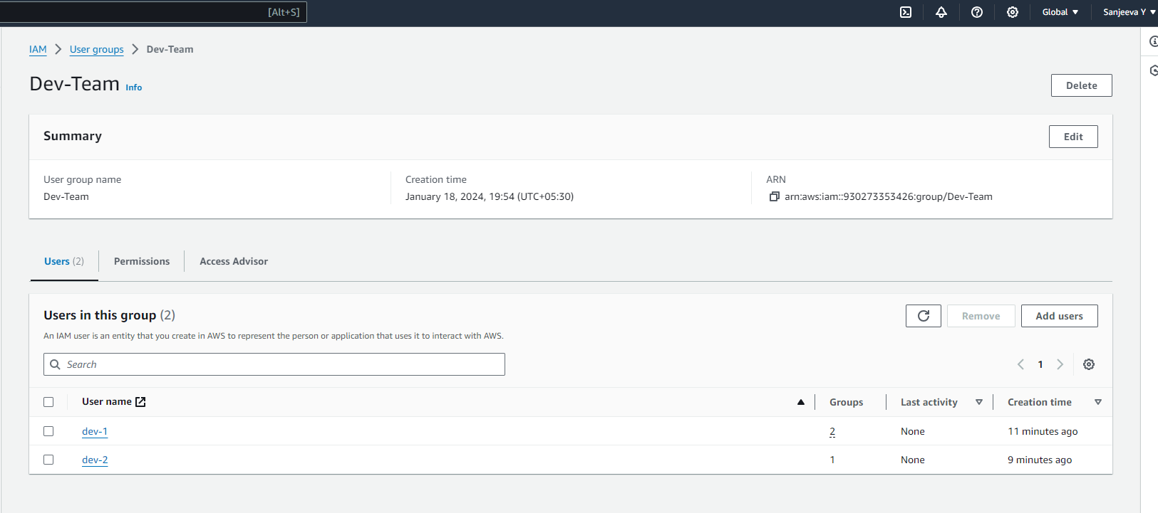

1. **Add Dev1, Test1 and Test2 to the Ops Team.**

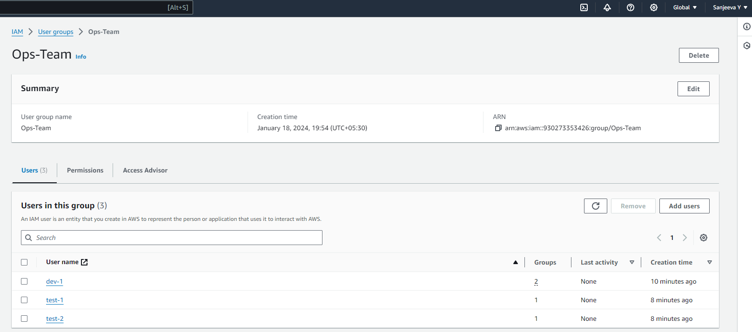

IAM Policies Assignment-2

1. **Create policy number 1 which lets the users to:**

**a. Access S3 completely**

**b. Only create EC2 instances**

**c. Full access to RDS**

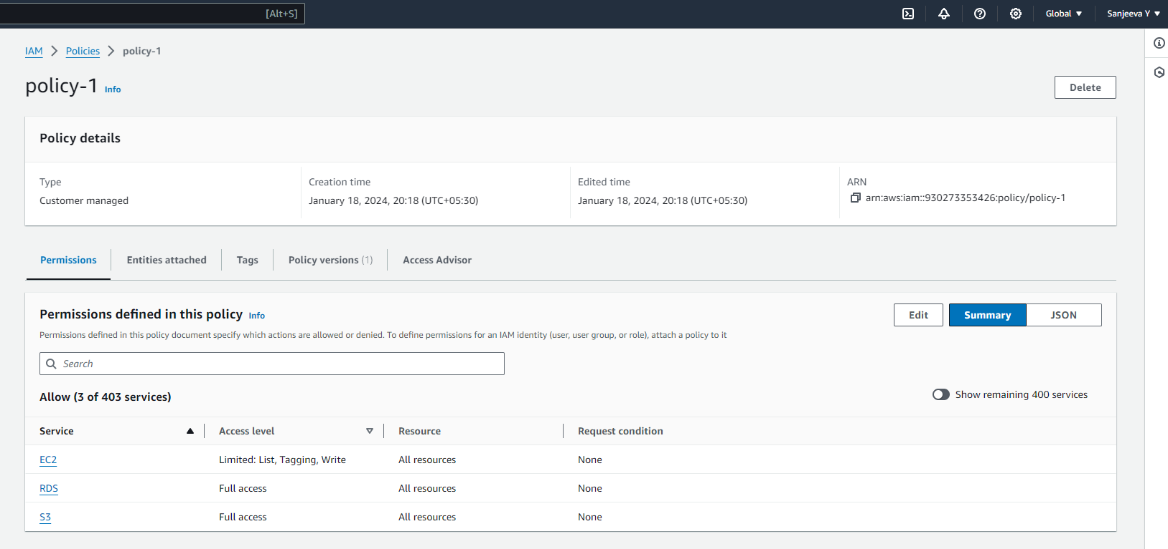

1. **Create a policy number 2 which allows the users to:**

**a. Access CloudWatch and billing completely**

**b. Can only list EC2 and S3 resources.**

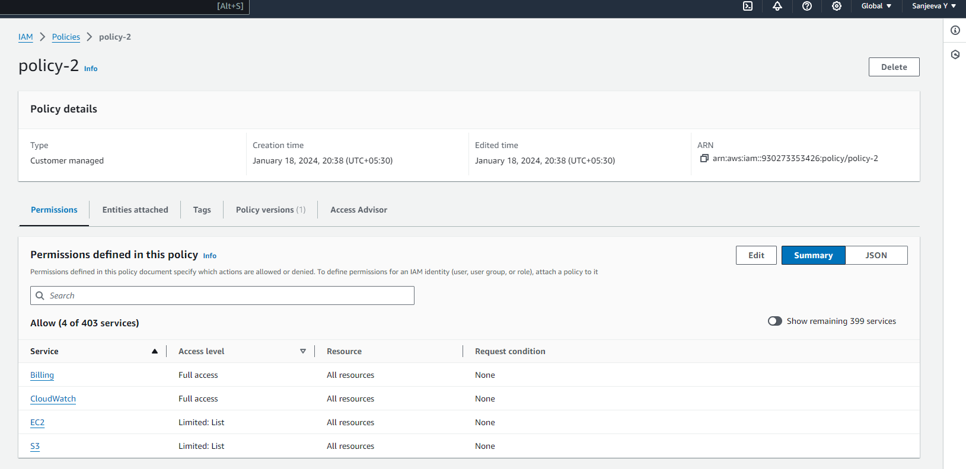

1. **Attach policy number 1 to the Dev Team from task 1**

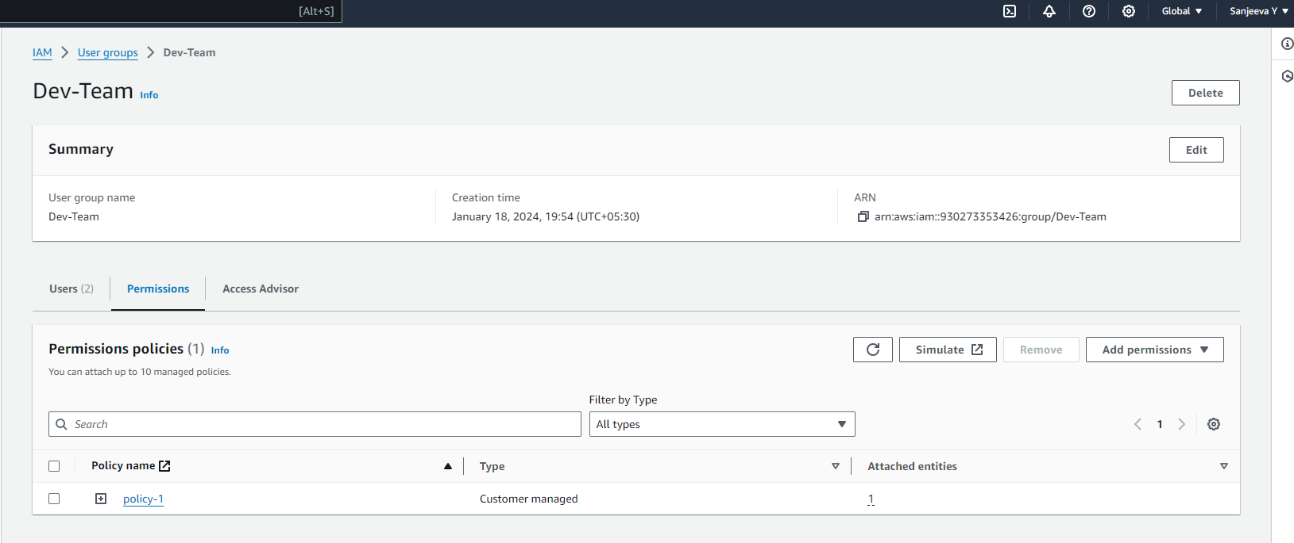

1. **Attach policy number 2 to Ops Team for task 1**

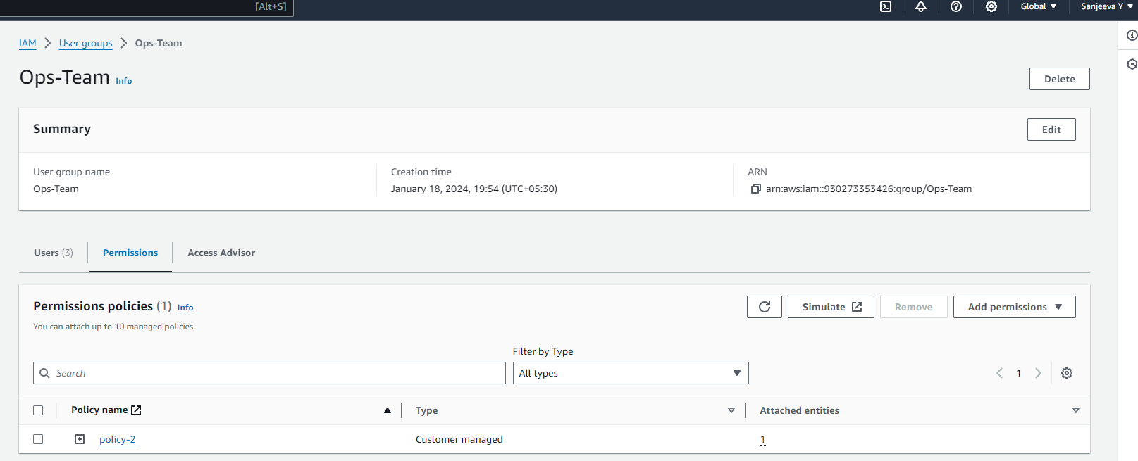

**IAM Roles Assignment-3**

**1. Create a role which only lets user1 and user2 from task 1 to have complete access to VPCs and DynamoDB.**

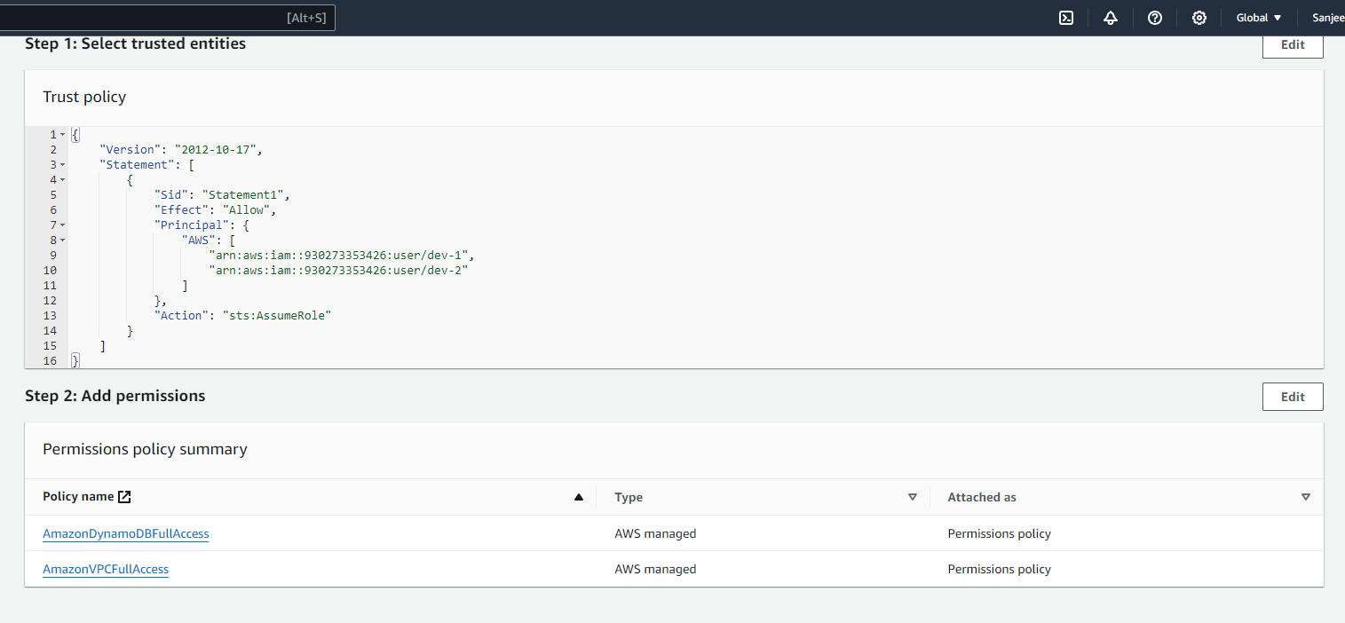

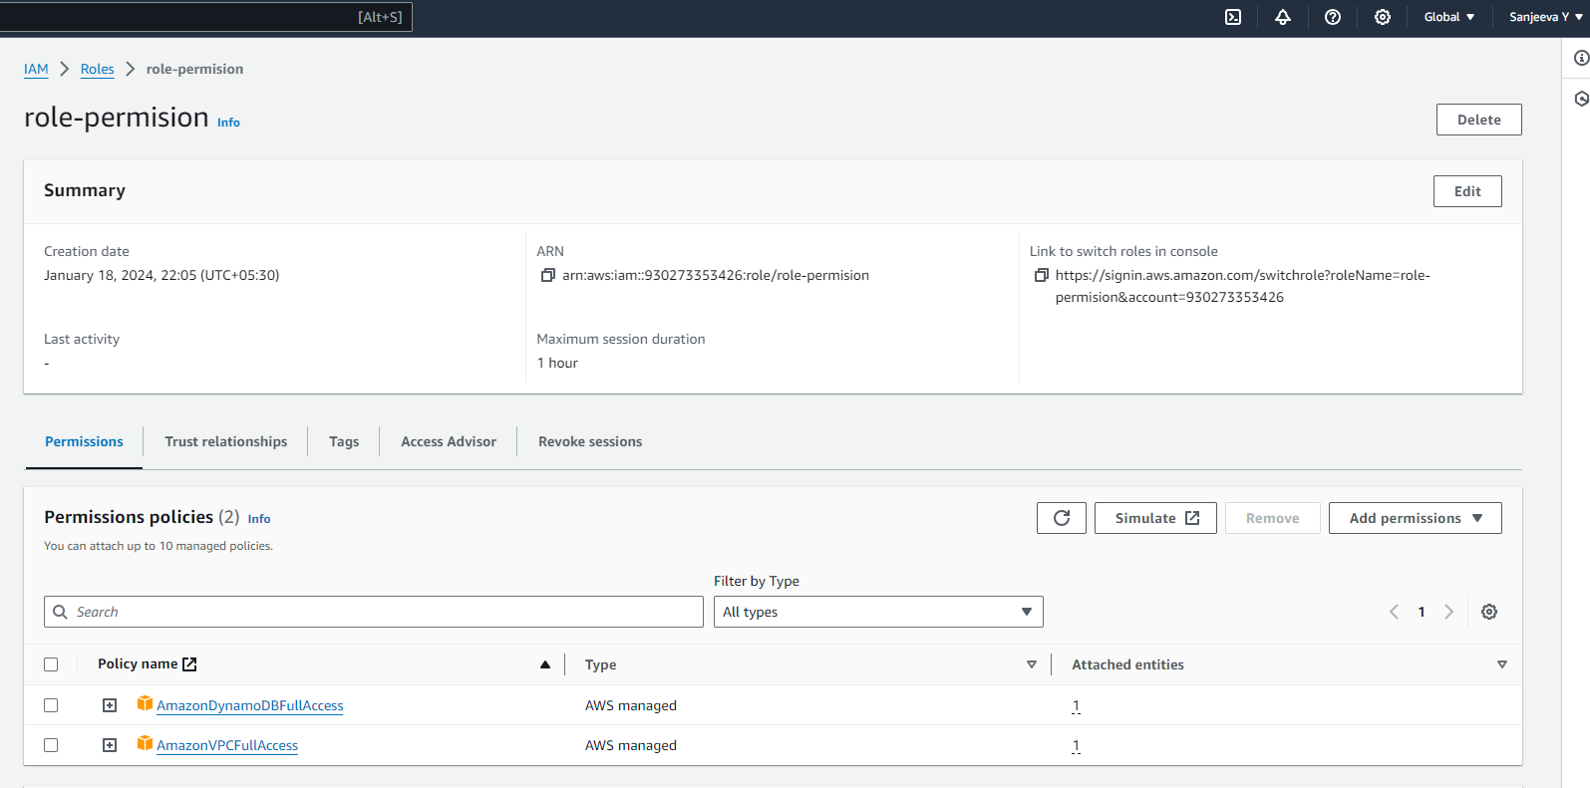

**2. Login into user1 and shift to the role to test out the feature.**

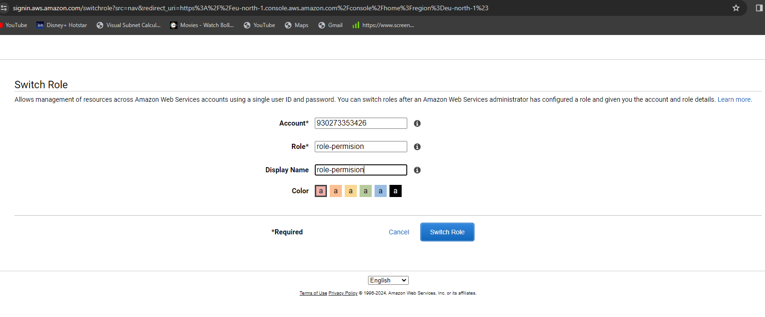

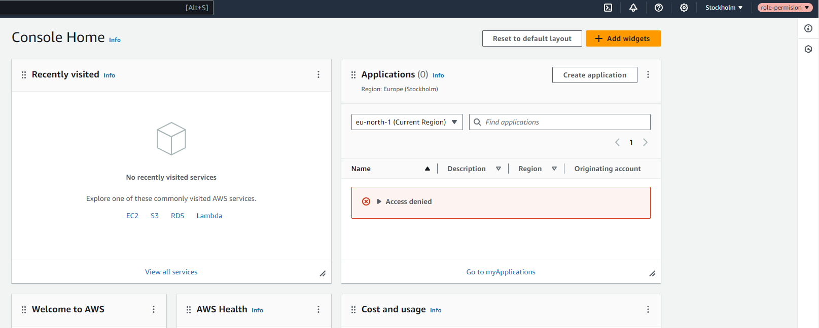

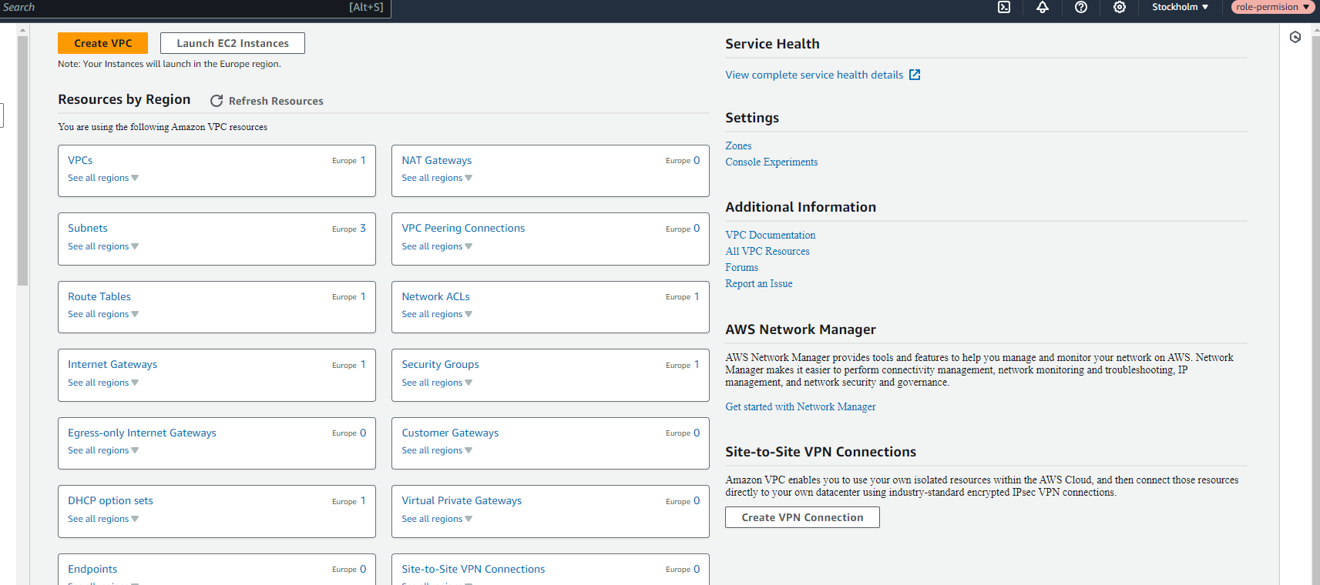

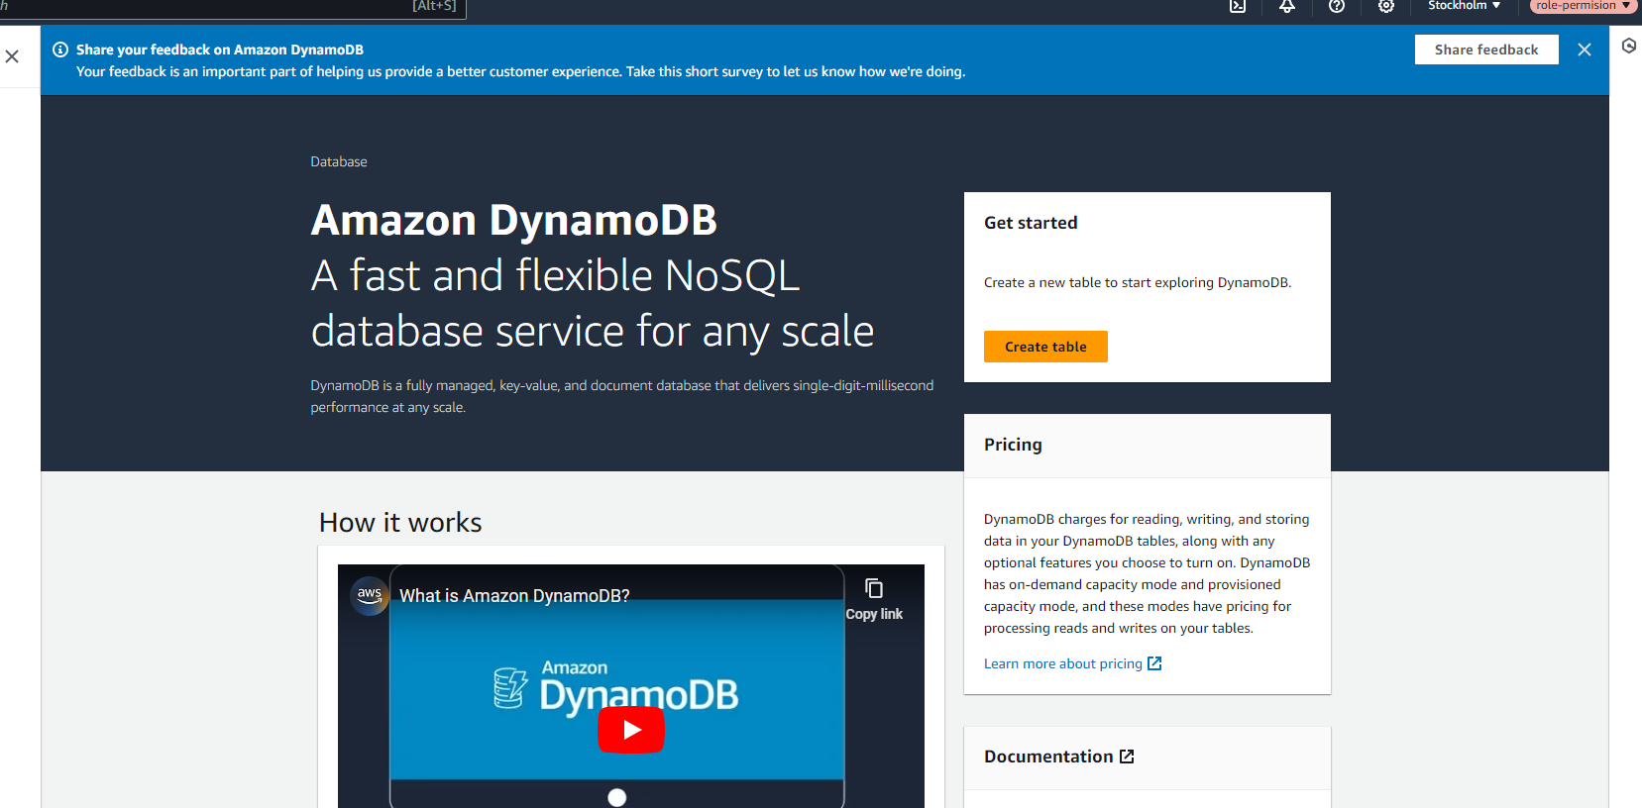

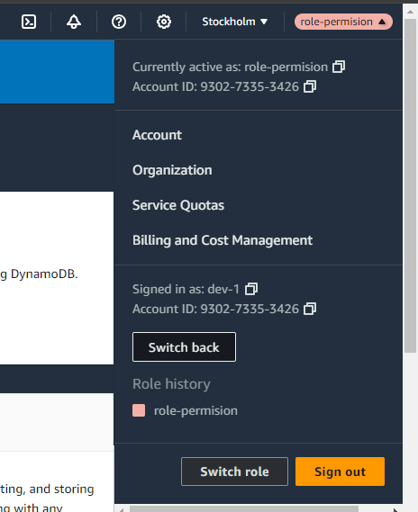

**CloudWatch Dashboard Assignment**

**. Create a dashboard which lets you check the CPU utilization and networking for a particular EC2 instance.**

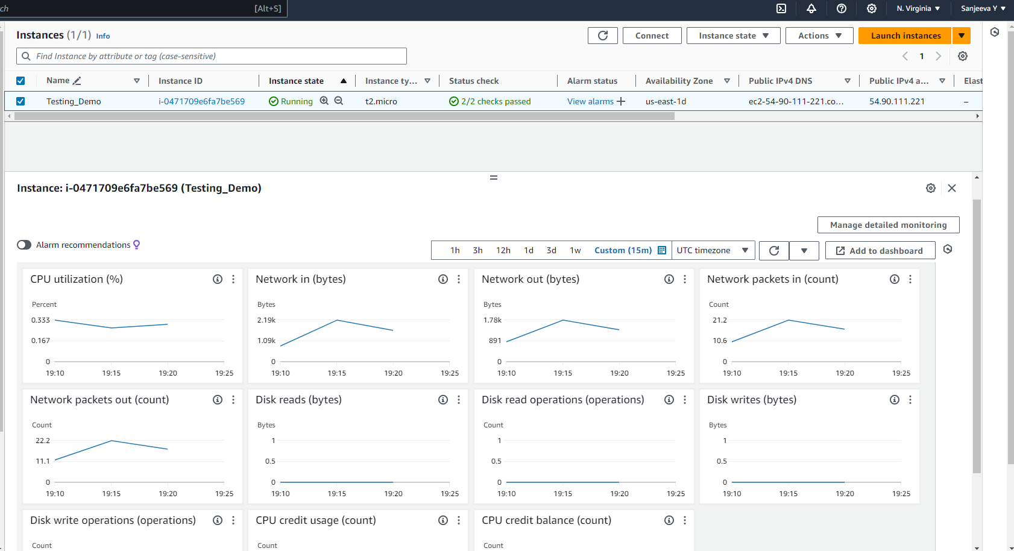

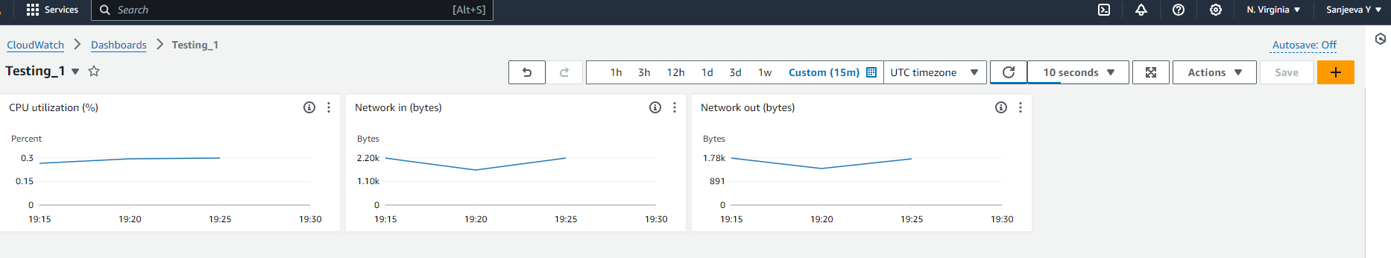

**CloudWatch Alarms Assignment**

**1. Create a CloudWatch billing alarm which goes off when the estimated charges go above $500.**

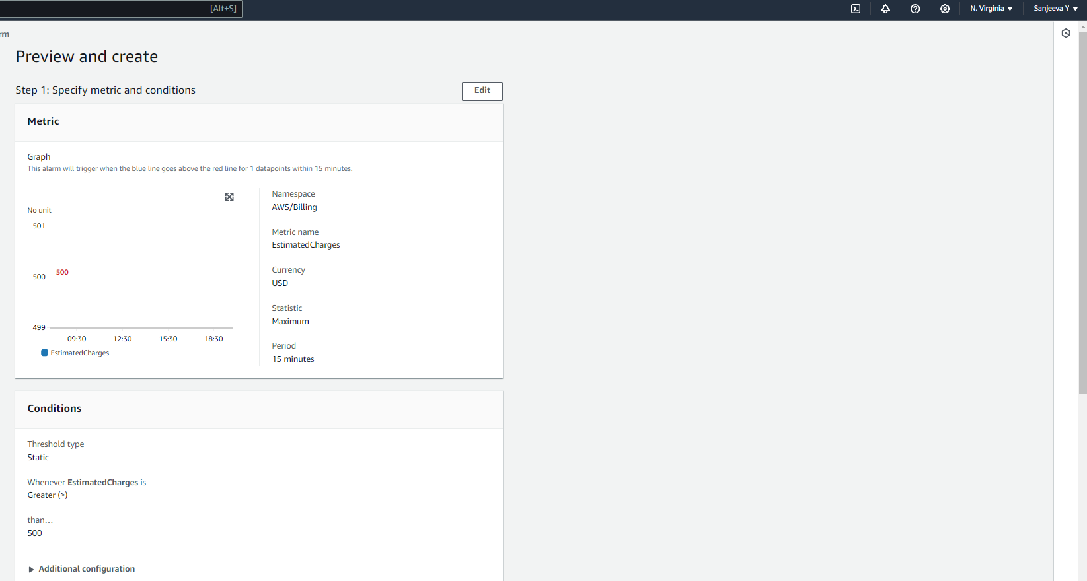

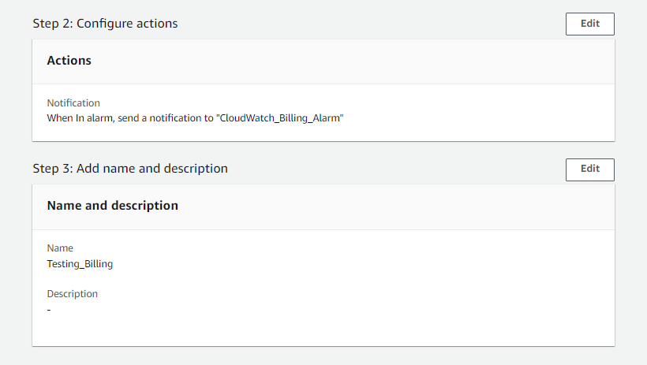

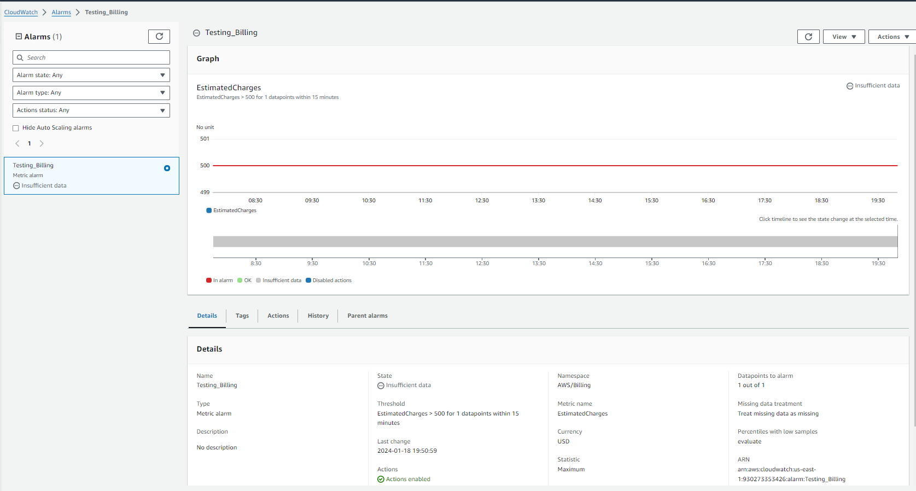

**2. Create a CloudWatch alarm which goes off to an Alarm state when the CPU utilization of an EC2 instance goes above 65%. Also add an SNS topic so that it notifies the person when the threshold is crossed.**

